GRADE 8 Name___________________________________ Date___________________________
8TH UNIT 4 CHART
Word + Other Forms  (parts of speech) | Connotation  (positive? Negative?) | Structure  (prefix, suffix, and root meanings) | Original Sentence  (use your brain) | Visual
annul |  |  |  | 
blase |  |  |  | 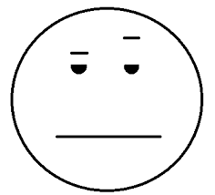
bolster |  |  |  | 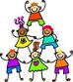
deplore |  |  |  | 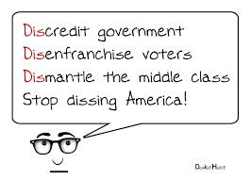
frivolous |  |  |  | 
Word + Other Forms | Connotation | Structure | Original Sentence | Visual
muster |  |  |  | 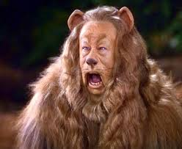

nonentity |  |  |  | 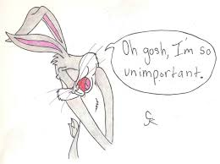
obsess |  |  |  | 
ornate |  |  |  | 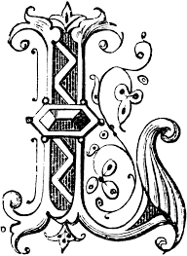
oust |  |  |  | 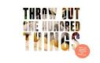

Word + Other Forms | Connotation | Structure | Original Sentence | Visual

peruse |  |  |  | 
porous |  |  |  | 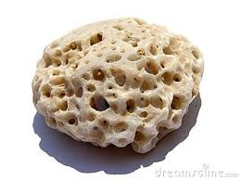
promontory |  |  |  | 
prone |  |  |  | 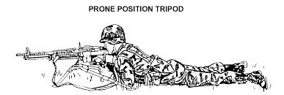

qualm |  |  |  | 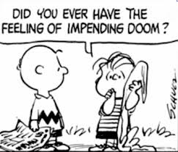
Word + Other Forms | Connotation | Structure | Original Sentence | Visual

recourse |  |  |  | 
residue |  |  |  | 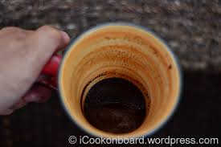

solicitous |  |  |  | 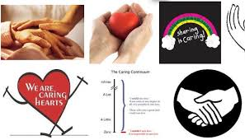
staid |  |  |  | 

sustain |  |  |  | 

